**CPE 301 Final Project**

**Roger Przybyla**

**Nick Kalvelage**

**Arduino MEGA Based Drone**

**Overview:**

The design of this drone was based upon the topics covered in CPE301. The drone was based upon the F450 Base which is a common base for DIY drones. Standard drone motors and ESC’s were used in conjunction with the Arduino and are controlled using pulse width modulation. The drone has a gyroscopic sensor, along with an APC220 wireless transmitter that sends the gyroscopic data to a computer. System constraints are shown below in Table 1.

Table 1: System Constraints

|  |  |  |
| --- | --- | --- |
| Device | Operating Voltage | Operating Current |
| Motors | 11.1V | 1.3A |
| ESC’s | 11.1V | 40A MAX |
| Gyroscope | 5V | 3.6mA |
| APC220 Transmitter | 5V | 42mA |

In addition, the drone operates on a 3s 11.1V Li-po battery. This supplies voltage to ESC’s and Arduino, which then powers all other devices. The pictures and video show drone operation without propellers because of the theft of much of our gear. We order what we could next-day on Amazon and I’m pleased with the end results given the circumstances.

**Pictures of the Drone:**

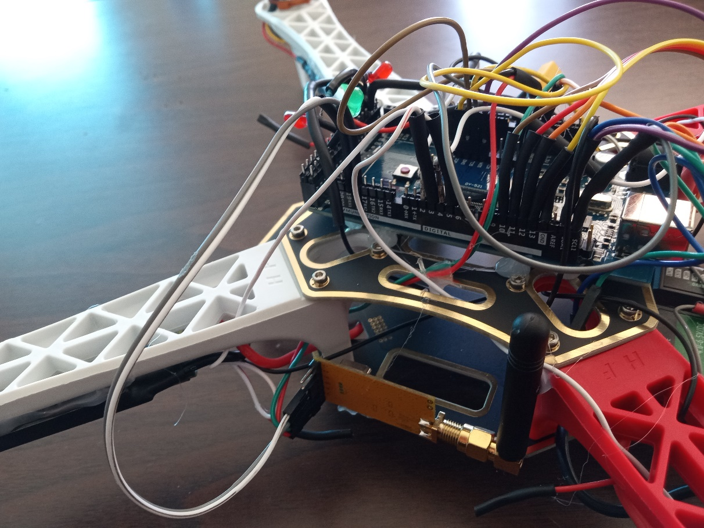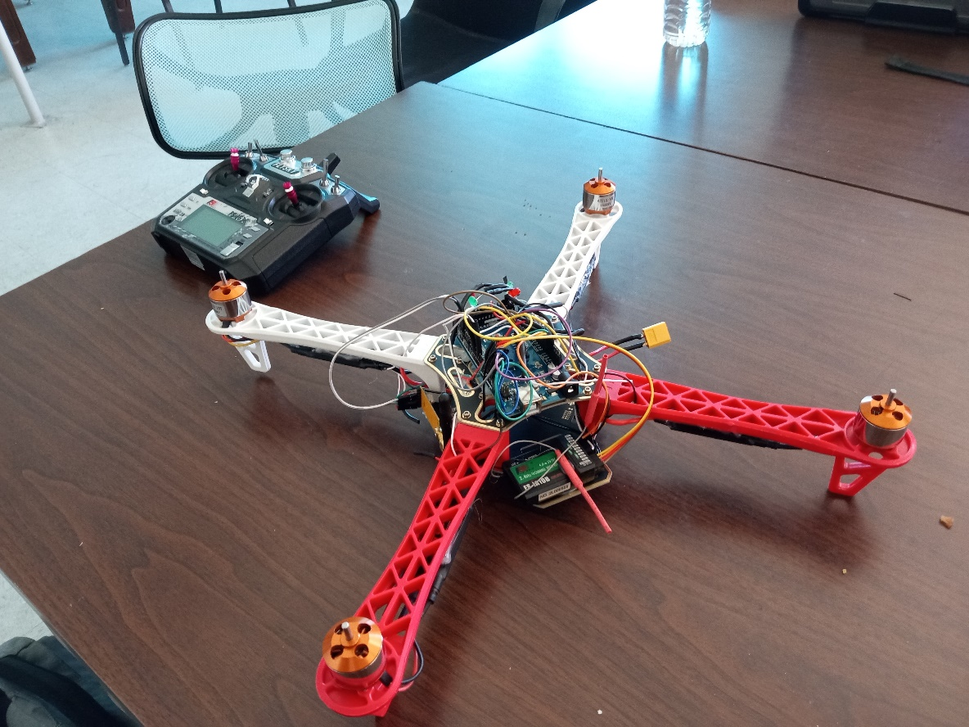

Figure 2: APC 220 and Wiring

Figure : Complete Drone

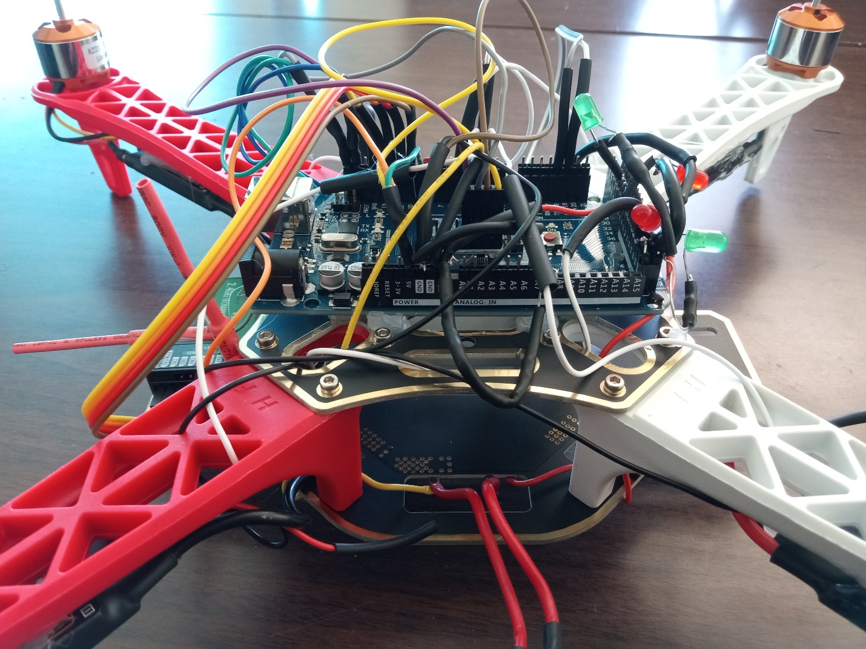

Figure 3: Battery Hook up/Wiring

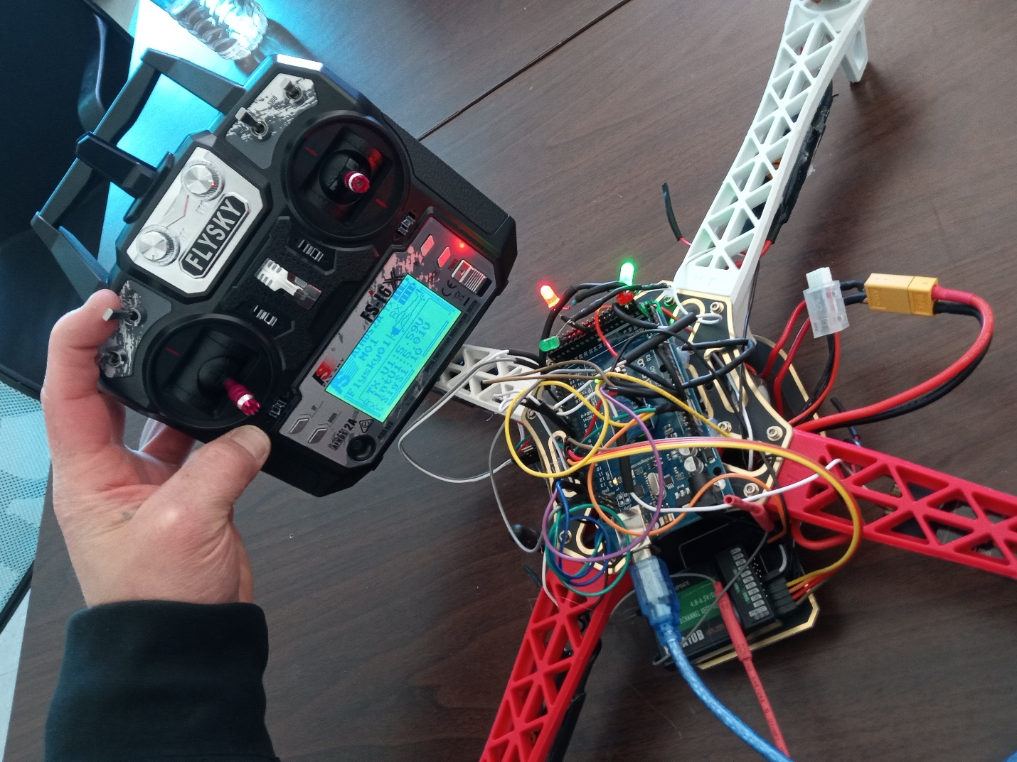

Figure 4: Drone Flight Controller/Program OFF RED LED OFF

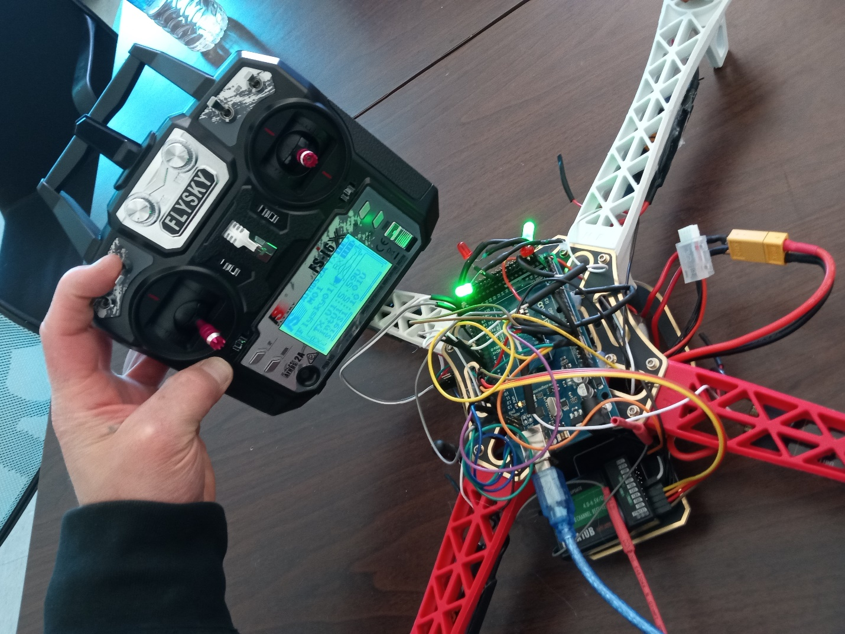

Figure 5: Drone Flight Controller ON GREEN LED ON

Figure 6: RF serial Communication showing gryo change of x,y,z axis in degrees.

Figure 7:Schematic

**DATA SHEETS:**

MPU-6050 (GYRO) : <https://invensense.tdk.com/wp-content/uploads/2015/02/MPU-6000-Datasheet1.pdf>

FLYSKY I6x: <https://files.banggood.com/2016/09/FS-i6X%20User%20manual.pdf>

APC 220: <https://image.dfrobot.com/image/data/TEL0005/APC220_Datasheet.pdf>

Arduino Mega: <https://docs.arduino.cc/static/c0906fc2a6b147687f7ac33f1d6690d9/A000067-datasheet.pdf>

Motors A2212: <https://www.rhydolabz.com/documents/26/BLDC_A2212_13T.pdf>

ReadySky 40a ESC: <https://www.readytosky.com/e_productshow/?301-Readytosky-2-6S-40A-Electronic-Speed-Controller-301.html>

**Video of Operation:**

**<https://youtu.be/BaTPE71lAmM>**

**GitHub Link:**

<https://github.com/rpriz/droneCPE301UNR>